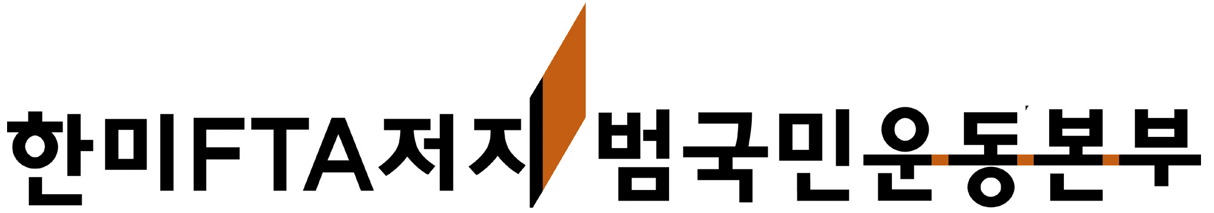

Korean Alliance against the Korea-U.S. FTA

150-982 Daeyoung Building 3F, 139 Youngdeungpo-dong 2-ga, Youngdeungpo-gu Seoul, Republic of Korea

Tel: 82-2-775-2501 nofta@hanmail.net www.nofta.or.kr

Let us unite to stop all U.S.-led free trade agreements!

Endorsement Protest Statement against the Korea-U.S. FTA

As you know, negotiations of the Korea-U.S FTA are near their end. If we do not act quickly, an agreement that values profit over people’s lives will come into effect with detrimental consequences for workers and farmers in both Korea and the United States. As we, the Korean Alliance against Korea-U.S. FTA (KoA) mobilize all our strength in this final stage we ask for your support and solidarity. Please have your organization sign the attached protest statement and circulate it to your allied organizations.

The 8th round of negotiations for the Korea-U.S. FTA concluded on March 12 with only a few issues left for further discussion in high-level talks. Both the U.S. and South Korea expect to reach an agreement by the end of the month, when all free trade agreements must be submitted to the U.S. Congress for a vote by the end of June to meet the deadline for the U.S. president’s Trade Promotion Authority. At the moment, the U.S. has concluded or is undergoing free trade negations with several countries, including Peru, Colombia, Panama, South Korea, Thailand, and Malaysia. For countries such as Peru and Colombia, signed agreements are already in the U.S. Congress and in respective legislatures for vote.

Time is a critical factor in the fight to stop all U.S.-led free trade agreements; March is the month in which we must stop all pending FTAs from conclusion. The reasons for our fight are clear: All the FTAs led by the Bush Administration’s USTR Office violate international standards on labor, environment, health, and safety. In Korea, the negotiations process has been wholly undemocratic, ignoring public opinion and hiding information. The livelihoods of farmers are at serious risk, and public services face disastrous reduction and privatization. As in other FTAs, the investor-state claims clause threatens all protective laws and social institutions. The Korea-U.S. FTA, the largest FTA since NAFTA, thus poses to bring unprecedented harm to all areas of life.

On March 12 we began an unlimited protest hunger strike, which will grow to as many as one thousand participants by the beginning of next week. On March 25, tens of thousands of farmers, workers, and concerned persons will gather for mass demonstrations against the Korea-U.S. FTA throughout the country. These events represent the widespread rage at the FTA negotiations, which have ignored the opinions and needs of common people from the very beginning.

The Korea-U.S. FTA is not merely important for people in Korea and the U.S., it is an issue of global concern. If this agreement passes it will represent an advance for the neoliberalist agenda of profits for big business at the expense of working people. If we can defeat it, it will mean a victory for common people in our struggle to achieve a more equitable world.

Once again, please join us in this struggle by signing the attached statement and circulating to organizations in your network. In addition, please let us know what we can do to support the anti-FTA struggles in which you are engaged.

In signing the statement please follow the instructions below:

1. Please have a representative of your organization sign in your organization’s name. (Include the individual’s name, title and the organization’s name).

2. Please return the signed statement to us by the evening of Saturday, March 24 2007. (Please be aware of time differences). The statement will be released to the media in timing with our mass mobilization on March 25.

3. Please send the statement to both of the following addresses: nofta@hanmail.net, openplaza@paran.com

4. If you have any questions you may contact Wol-san Liem 82-10-2261-0613 or Cheehyung Kim at 82-10-5233-6846

International Solidarity Team

Korean Alliance against the Korea-U.S. FTA

150-982 Daeyoung Building 3F

139 Youngdeungpo-dong 2-ga, Youngdeungpo-gu,

Seoul, Republic of Korea
nofta@hanmail.net www.nofta.or.kr

Formed on March 28, 2006, the Korean Alliance against KorUS FTA (KoA) is made up of over 300 organizations, including trade unions, farmers’ groups, NGOs, and social movement groups. Prior to the FTA struggle, South Korea’s farmers, workers, and activists have fought against the WTO in Seattle, Cancun, and Hong Kong. Through our activities, we have joined the struggle against neoliberal globalization throughout the world. At the core of our fight against the FTA is the people’s demand for fair international trade based on sustainable development, public service, cultural diversity, and food sovereignty.

