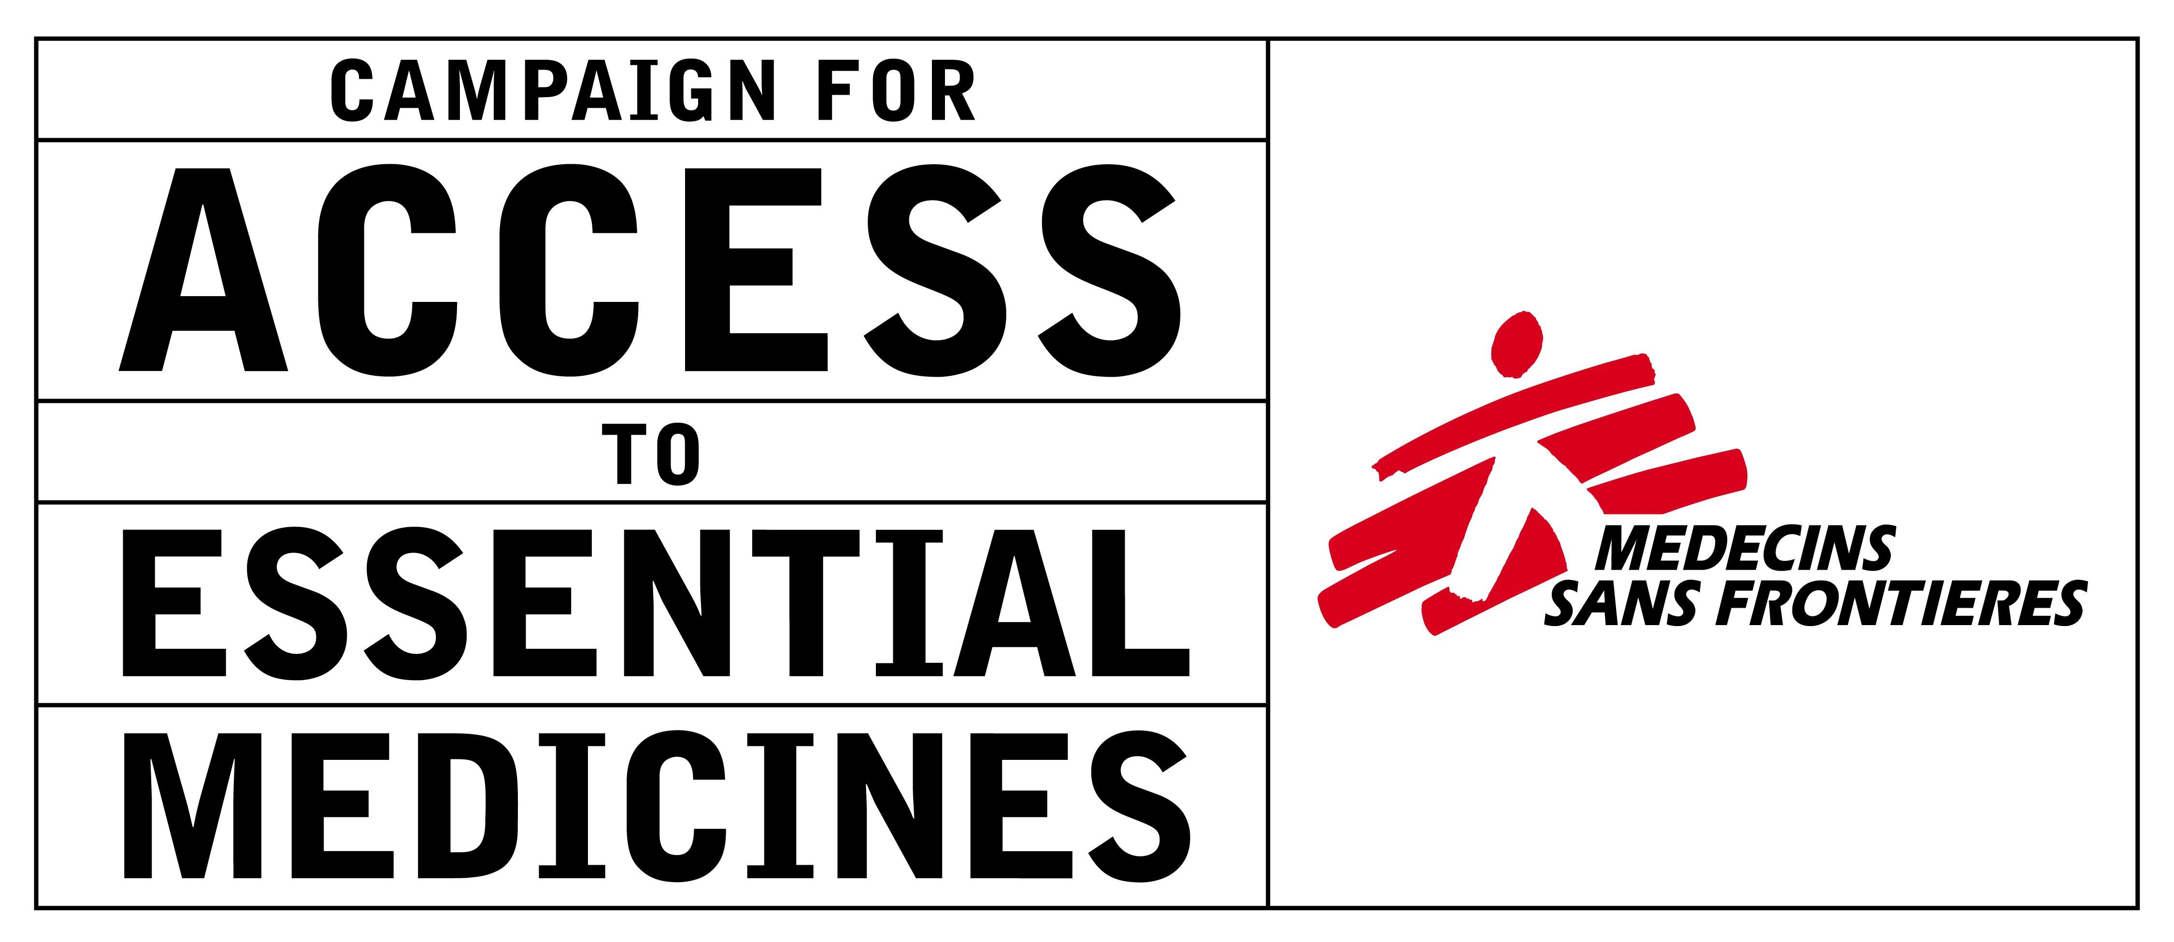

EUROPE! HANDS OFF OUR MEDICINE

India has been called the ‘pharmacy of the developing world’ – over 80% of the medicines used by Médecins Sans Frontières to treat 170,000 people living with HIV/AIDS come from India, and international donors rely on Indian generics in similar proportions. But because of the Europe-India free trade agreement (FTA) currently being negotiated, Indian generic companies may no longer be able to provide the affordable medicines people will need.

From Brussels to Bangkok and Nairobi to New Delhi, people living with HIV and other life-threatening diseases have taken to the streets to protest the measures in this trade deal that could restrict people’s access to the affordable medicines they need to stay alive. On 7-8 April 2011, negotiators from India and the European Union are meeting again in Brussels to resume talks.

Data Exclusivity: A Backdoor To Getting Monopoly Status
Data exclusivity (DE) is a backdoor way for multinational pharmaceutical companies to get a monopoly and charge high drug prices, even when their drug has been found to not deserve a patent, or the patent has expired – DE would apply to all drugs.

If India accepts DE, the agency in charge of approving medicines for use in the country would not be allowed to register a generic version of a medicine for a period of time - usually 5 to 10 years. To register a generic, producers rely on the clinical trial data provided by the originator company to show the drug is safe and effective. All the generic has to prove is that it is identical to the originator product. But if DE were in place, the originator company’s clinical trial data would be protected by ‘exclusivity’ and generic producers would therefore have to submit their own safety & efficacy data to register the generic medicines. This would oblige them to repeat clinical trials—something that would take years and be incredibly expensive, not to mention unethical, as it would involve withholding a drug that has already proven to be effective from some of the participants in the trial.

Europe is pushing for DE because it is a way of getting around the public health safeguards India built in to its patent law in 2005, which have long vexed the pharmaceutical industry in wealthy countries. One of these safeguards prevents pharmaceutical companies from obtaining patents in India for medicines that are not actual inventions, such as the combination of existing drugs into one pill, or slightly modified formulations of existing medicines. India stipulated that patents should only be granted on medicines that are truly new & innovative. As a result, several patent applications have been rejected in India.

But if India accepts DE, the public health safeguards in India’s law will be directly undermined. Multinational pharmaceutical companies would be able to use data exclusivity instead of patents to stamp out competition from generic producers – again, even if a drug has not been granted a patent or if the patent has already expired! The example of colchicine, a therapeutic agent that has been used for more than 3,000 years to treat gout, clearly illustrates the impact DE can have on access to medicines. Although a tablet formulation has been widely available as a generic prescription drug since the 19th century in the United States, colchicine was recently granted marketing exclusivity after the US Food and Drug Administration accepted a one-week trial of the drug done by a company and was then bound to grant DE. The company then enforced its exclusivity rights, which forced other manufacturers off the market. The price then rose 50 times from $0.09 to $4.85.

In Jordan, where data exclusivity was introduced as part of the US-Jordan FTA, a study found that of 103 medicines registered & launched since 2001 that currently have no patent protection in Jordan, at least 79% have no competition from a generic equivalent as a consequence of data exclusivity.

The latest: On 29 March 2011, Indian Commerce & Industry Minister Shri Anand Sharma issued an official statement arguing that data exclusivity is “well beyond” international trade rule obligations and that the “grant of data exclusivity would have considerable impact in delaying the entry into the market of cheaper generic drugs.”

In a statement released on 1 April 2011, Médecins Sans Frontières (MSF) cautiously welcomed the declaration. “We support India in standing strong in the face of constant pressure from the EU Commission on data exclusivity,” said Leena Menghaney, Manager of MSF’s Campaign for Access to Essential Medicines in India. “We urge Minister Sharma to stick to this position for this and for future free trade agreements that India will negotiate.”

“This is a welcome statement from Minister Sharma, but it is too early to celebrate, because the EU has not made clear yet that it will stop pushing data exclusivity in the negotiations,” said Michelle Childs, Director of Policy/Advocacy at MSF’s Campaign for Access to Essential Medicines.

→ The EU should officially confirm that they will drop their demands for data exclusivity in the EU-India FTA.

Investment Rules: A Fast-Track For Drug Companies To Sue the Indian Government
Europe is also pushing for the trade deal to include provisions that would allow foreign companies to take the Indian government to private arbitration courts over domestic health policies like tobacco warnings & measures to reduce prices of medicines. Companies want what is known as “investor-to-state” dispute mechanisms to help protect their investments. This mechanism gives companies the right to sue the Indian Government if a company’s ‘investment’, which is defined in the trade agreement, is in the company’s view, threatened by an action or policy of the Indian Government. In the investment chapter of the agreement, the definition of investment includes intellectual property, so multinational drug companies will also be able to raise investment disputes with the Indian government over matters related to intellectual property.

Here is one illustration of how companies can use such provisions to challenge the health policies of governments on grounds of “intellectual property” infringement: in February 2010, tobacco company Philip Morris used the investor-state dispute mechanism under a Switzerland-Uruguay Bilateral Investment Treaty to file a case against Uruguay’s decision to increase the size of tobacco warning labels on cigarette packets. Philip Morris argues that these measures by governments- increasing the size of health warnings & moves to remove branding from cigarette packets - is "expropriation" of trademarks (its branding) and an abuse of their investment rights.

These disputes typically take place in secret, before private arbitration panels – meaning that the Indian national courts are bypassed - and usually involve claims for millions of dollars in damages. Pharmaceutical companies must be given no additional avenues to bully developing country governments on policies and laws that promote access to medicines. India is already reeling from multiple litigations filed by companies like Novartis and Bayer against health safeguards in India’s patent law. While Indian courts have placed public health and access to medicines as priorities over corporate profits, these principles are unlikely to be applied in private arbitration panels.

The latest:
The European Commission (EC), which is negotiating the trade deal in the name of EU countries, is now asking for a green-light from the European Council of Ministers to move forward with a broader negotiating mandate. This would allow it to push for greater intellectual property protection as a part of the ‘investment chapter’ in the EU-India trade deal.

In April 2011, the European Parliament passed a Resolution expressing its own concerns surrounding investment provisions and called on the EC to ensure there was no harmful impact on access to medicines.

→ The EU should remove ‘intellectual property’ from the definition of investment it is pushing as a part of the free trade agreement with India.

