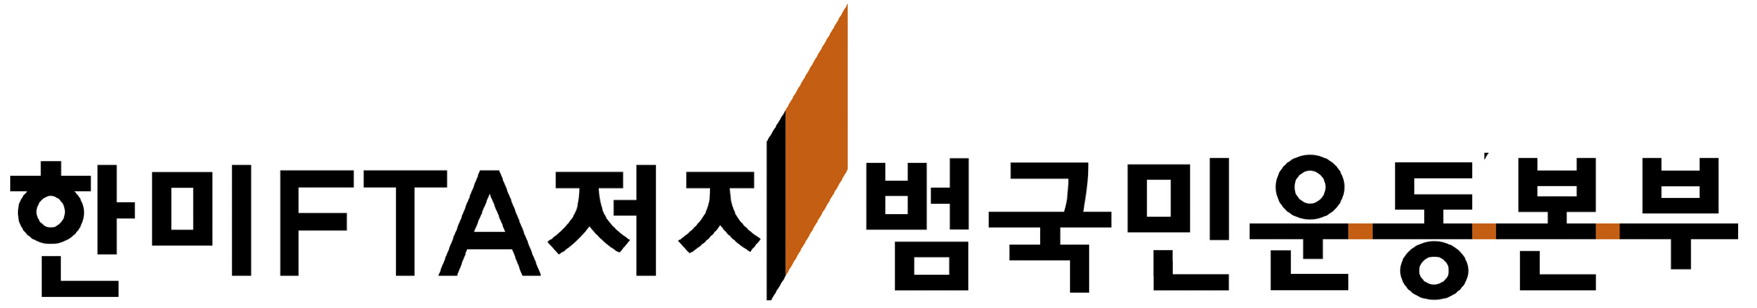

Korean Alliance against the Korea-U.S. FTA

150-982 Daeyoung Building 3F, 139 Youngdeungpo-dong 2-ga, Youngdeungpo-gu Seoul, Republic of Korea

Tel: 82-2-775-2501 nofta@hanmail.net www.nofta.or.kr

Let us unite to stop all U.S.-led free trade agreements!

International Day of Action against the Korea-U.S. FTA and All U.S. FTAs

Proposal for the International Day of Action on Sunday, March 25, 2007

We, the Korean Alliance against Korea-US FTA (KoA), call for an international day of joint action on Sunday, March 25, 2007. To the people struggling to stop the spread of neoliberal globalization, we ask for your solidarity and strength in stopping the Korea-U.S. FTA and all U.S. FTAs.

The 8th round of negotiations for the Korea-U.S. FTA begins on March 8. Both the U.S. and South Korea expect to reach an agreement by the end of March, when all free trade agreements must be submitted to the U.S. Congress for a vote by the end of June to meet the deadline for the U.S. president’s Trade Promotion Authority. At the moment, the U.S. has concluded or is undergoing free trade negations with several countries, including Peru, Colombia, Panama, South Korea, Thailand, and Malaysia. For countries such as Peru and Colombia, signed agreements are already in the U.S. Congress and in respective legislatures for vote.

Time is a critical factor in the fight to stop all U.S.-led free trade agreements; March is the month in which we must stop all pending FTAs from conclusion. The reasons for our fight are clear: All the FTAs led by the Bush Administration’s USTR Office violate international standards on labor, environment, health, and safety. In Korea, the negotiations process has been wholly undemocratic, ignoring public opinion and hiding information. The livelihoods of farmers are at serious risk, and public services face disastrous reduction and privatization. As in other FTAs, the investor-state claims clause threatens all protective laws and social institutions. The Korea-U.S. FTA, the largest FTA since NAFTA, thus poses to bring unprecedented harm on all areas of life. Let us unite in the struggle to stop all U.S.-led free trade agreements!

On March 25, 2007, tens of thousands of farmers, workers, and concerned persons will gather for mass demonstrations against the Korea-U.S. FTA throughout the country. These events will represent widespread rage at the FTA negotiations, which have ignored the opinions and needs of common people from the very beginning. We ask you to join us in protest on this day.

Proposal for the International Day of Action on Sunday, March 25, 2007

Title: International Day of Action against the Korea-U.S. FTA and All U.S. FTAs

Message: Stop the Korea-U.S. FTA and All U.S. FTAs

What: 1) Rallies, protests, marches, candlelight vigils, or whatever action is appropriate for the country; 2) endorsement of the attached protest letter

When: Sunday, March 25, 2007 (in conjunction with mass demonstrations in Korea)

Who: Organizations and activists from around the world who are fighting U.S. FTAs

Where: The U.S. Embassy, respective countries’ Embassies or Consulates, or other appropriate places

If you will participate in the International Day of Action, please confirm by Friday, March 16, 2007. KoA will send headbands that say “No FTA.” Even if you are unable to carry out an action, we ask for your endorsement of the protest letter.

Email confirmations and questions to nofta@hanmail.net

International Solidarity Team

Korean Alliance against the Korea-U.S. FTA

150-982 Daeyoung Building 3F

139 Youngdeungpo-dong 2-ga, Youngdeungpo-gu,

Seoul, Republic of Korea
Tel: 82-2-775-2501
nofta@hanmail.net www.nofta.or.kr

Formed on March 28, 2006, the Korean Alliance against KorUS FTA (KoA) is made up of over 300 organizations, including trade unions, farmers’ groups, NGOs, and social movement groups. Prior to the FTA struggle, South Korea’s farmers, workers, and activists have fought against the WTO in Seattle, Cancun, and Hong Kong. Through our activities, we have joined the struggle against neoliberal globalization throughout the world. At the core of our fight against the FTA is the people’s demand for fair international trade based on sustainable development, public service, cultural diversity, and food sovereignty.

