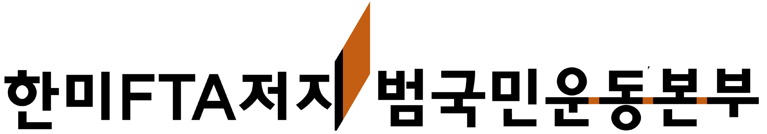

Korean Alliance against the Korea-U.S. FTA

150-982 Daeyoung Building 3F, 139 Youngdeungpo-dong 2-ga, Youngdeungpo-gu Seoul, Republic of Korea

Tel: 82-2-775-2501 nofta@hanmail.net www.nofta.or.kr

Declaration Opposing the Korea-U.S. FTA
March 2007

We, the undersigned, express our opposition to the Korea-U.S. Free Trade Agreement, which poses a serious threat to public interest in both South Korea and the United States. The Korea-U.S. FTA is based on a model of trade agreement that is designed to profit of transnational capital and big business at the expense of workers, farmers, and common people and has been negotiated through a secretive and undemocratic process. Such a trade agreement must not be implemented.

We are opposed to the secretive and undemocratic nature through which the Korea-U.S. FTA has been negotiated.
FTA talks have been held in remote places away from public view or outside of the official negotiations. The South Korean government has routinely withheld relevant information and documents from stakeholders, the National Assembly, and the general public. It has also closed off public debate through insufficient hearings and media censorship. Worse, it has severely suppressed anti-FTA sentiment, banning peaceful protests and arresting protest participants.

We are opposed to a trade agreement that will destroy the livelihood of South Korean farmers and harm the environment.
The Korea-U.S. FTA calls for unconditional opening of the South Korean agricultural market to cheap overproduced American-grown products. The consequent deterioration of Korean agriculture will have devastating social, cultural, and environmental effects: Statistics show that roughly half of South Korea’s farmers will be unable to maintain their farms and be forced to join the ranks of the urban poor. The resultant destruction of rural communities will mean the break-up of rural traditions that are the basis of Korean culture, and the deterioration of the rural environment. The Korea-U.S. FTA also threatens the environment by introducing mechanisms that can potentially lower environmental standards such as the Investor-State Claim Clause.

We are opposed to a trade agreement that directly threatens vital public services such as health-care, energy provision, and education.
The Korea-U.S. FTA calls for higher pricing of pharmaceuticals—benefiting transnational pharmaceutical companies at the expense of access for common people. The FTA will also limit the Korean government’s ability to ensure equitable access to energy and water supply by fostering privatization in these sectors and diminish the validity of public education through the introduction of private U.S.-based testing services, which will increase the demand on students to seek private education programs

We are opposed to a trade agreement that threatens cultural diversity by allowing harmful infringement on South Korea’s cultural industry.
Reduction of South Korea’s screen quota, which protects the nation’s film industry, was made a prerequisite for beginning FTA negotiations. Further, the current Korea-U.S. FTA will require the removal of similar protections for Korea’s broadcasting industry. These measures endanger the public function of the broadcasting industry and the uniqueness of South Korea’s audio-video language. The provisions of the Korea-U.S. FTA are inconsistent with the UNESCO Convention on the Protection and Promotion of the Diversity Cultural Expressions, which affirms the right of each member nation to formulate and implement regulations aimed at promoting domestic cultural expression.

We are opposed to a trade agreement that grants undue powers to investors at the expense of domestic development and public interest.
The unconditional investor-state claims clause included in the Korea-U.S. FTA affords greater privileges to foreign investors than those granted by domestic law, providing a mechanism through which investors’ claims can place enormous monetary penalties on taxpayers and pressure the government to adopt lower environmental and labor standards to avoid future claims. The Korea-U.S. FTA also calls for a reduction in government procurement contracts in order to open these markets to foreign capital. In South Korea, procurement policy promotes the growth of thousands of small businesses in various regions, providing entrepreneurial opportunities to businesses that are conscious about environmental and labor issues. As such, they are vital to keeping public interest alive and maintaining community-government cooperation.

We, the undersigned, stand in solidarity with the Korean people. We call for abrogation of the Korea-U.S. FTA negotiations to date and cancellation of all future talks and legislative processes.

Signed:

